

Bachelor of Information and Communication Technology (BICT) Honours Degree

CTEC 22043: Object Oriented Programming
Student No: CT/2022/001
Student Name: H.L.Ranasingha

Questions
- Write Java expressions to compute each of the following. a. The square root of B2 + 4AC (A and C are distinct variables) b. The square root of X + 4Y3 c. The cube root of the product of X and Y d. The area of a circle.

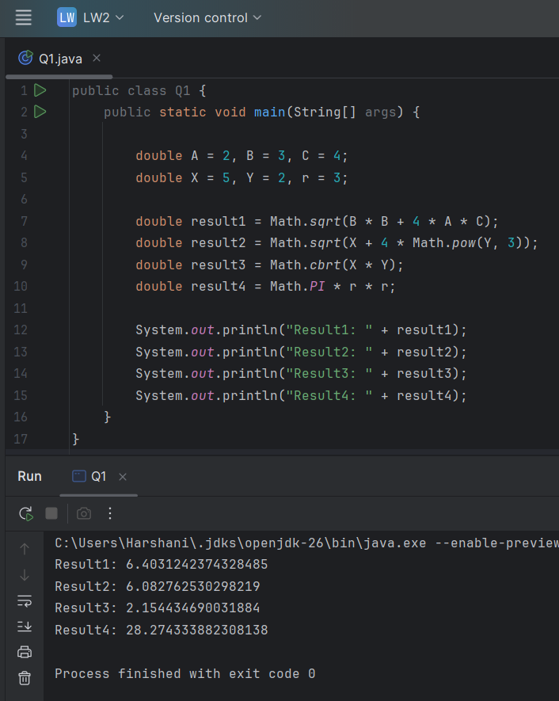
- Write a program to convert centimeters (input) to feet and inches (output).
1 in 2.54 cm.

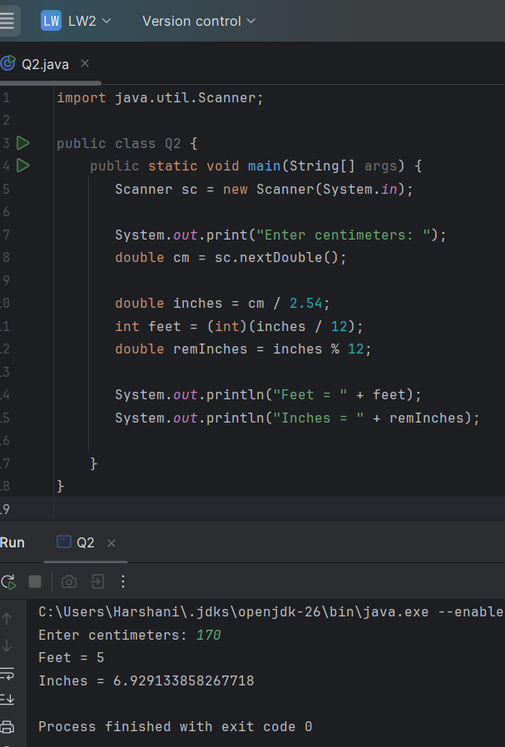

3. Write a program that inputs temperature in degrees Celsius and prints out the temperature in degrees Fahrenheit. The formula to convert degrees Celsius to equivalent degrees Fahrenheit is,
Fahrenheit = (1.8 x Celsius) + 32

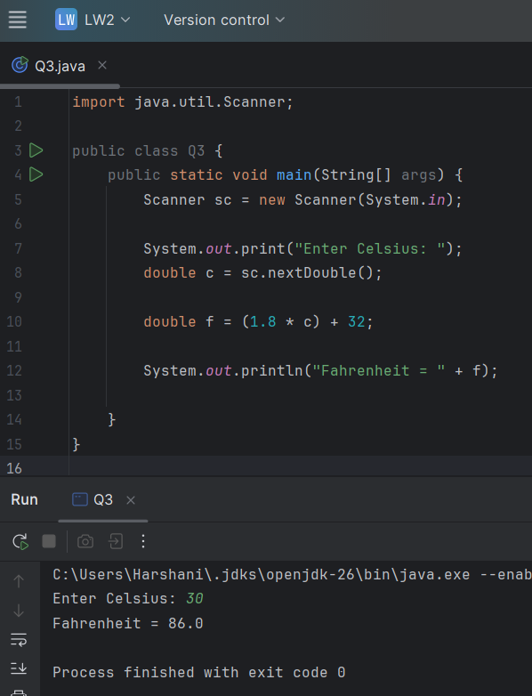

4. Write a program that accepts a person’s weight and displays the number of calories the person needs in one day. A person needs 19 calories per pound of body weight, so the formula is,
calories = bodyWeight x 19

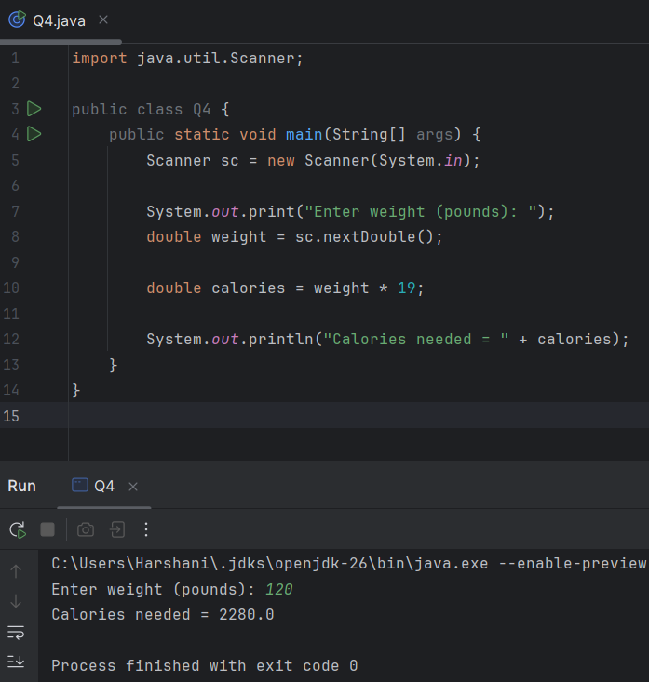

5. Write a program that inputs temperature in degrees Fahrenheit and prints out the temperature in degrees Celsius. The formula to convert degrees Fahrenheit to equivalent degrees Celsius is,
Celsius = (5 / 9) x (Fahrenheit - 32)

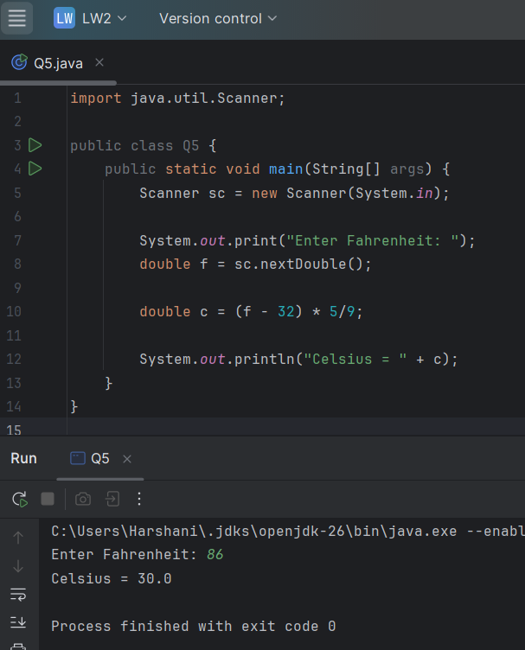

6. Write a program that inputs the year a person is born and outputs the age of the person in the following format:

You were born in 1990 and will be (are) 18 this year.

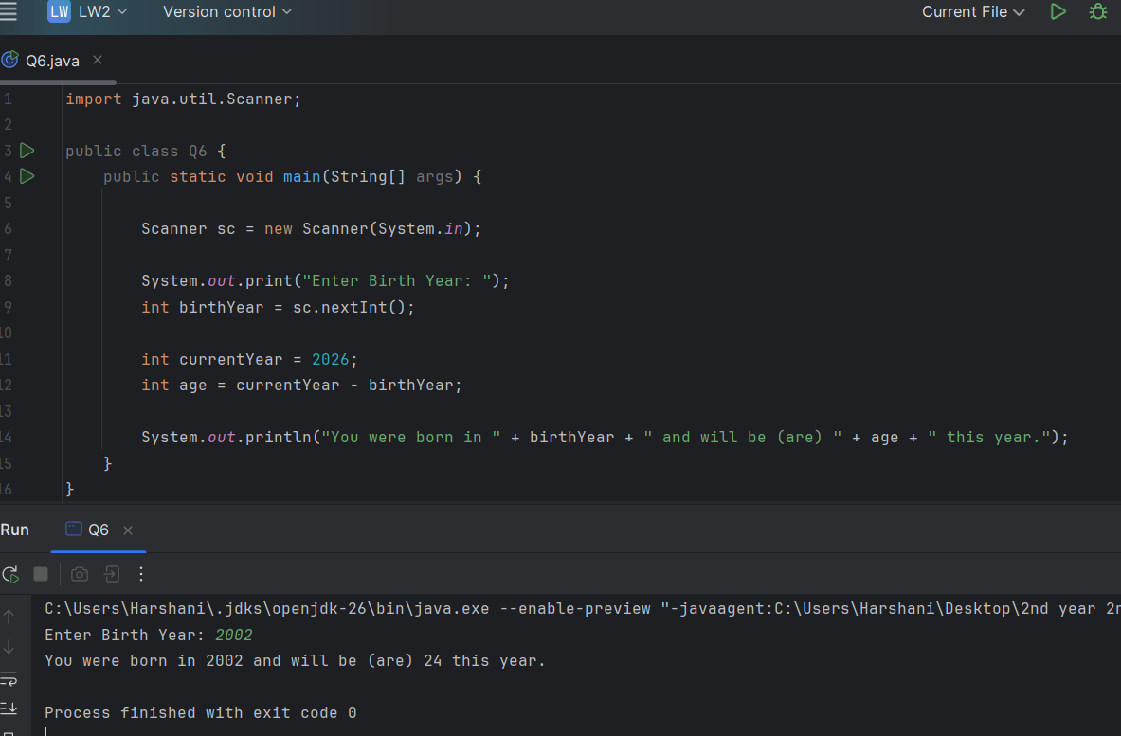

7. A quantity known as the body mass index (BMI) is used to calculate the risk of weight-related health problems. BMI is computed by the formula,
BMI = w / (h /100.0)2
where w is weight in kilograms and h is height in centimeters. A BMI of about 20 to 25 is considered “normal.” Write an application that accepts weight and height (both integers) and outputs the BMI.
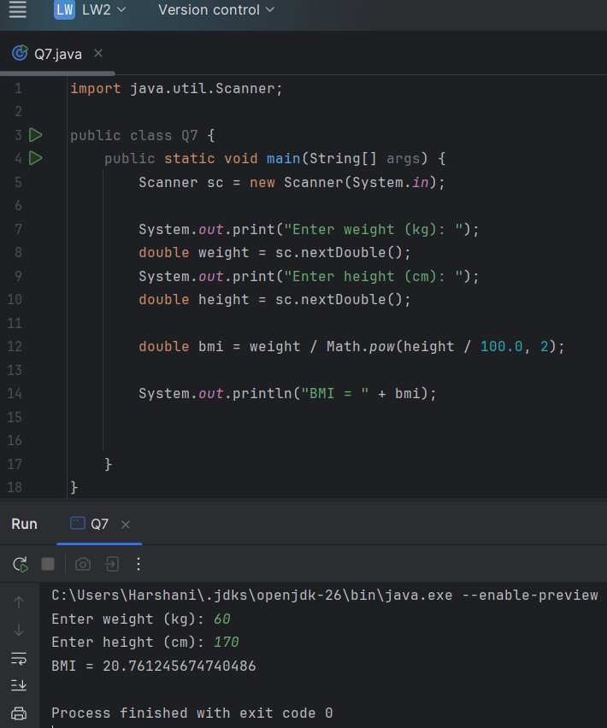
8. The volume of a sphere is computed by the equation,
V = (4 / 3) x (PI x r3)
where V is the volume, PI is the Pi value (3.14) and r is the radius of the sphere. Write a program that computes the volume of a sphere with a given radius r.

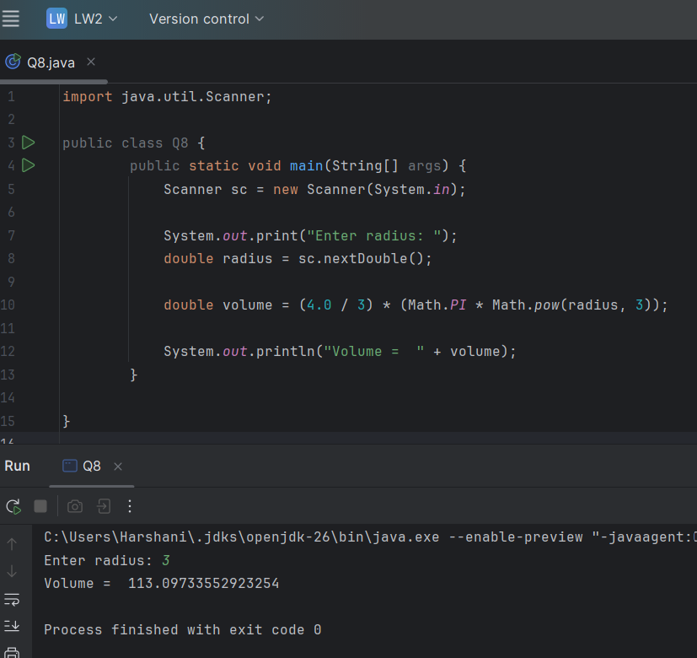

9. If you invest P dollars at R percent interest rate compounded annually, in N years, your investment will grow to P(1 + (R / 100))N dollars. Write an application that accepts P, R, and N and computes the amount of money earned after N years.
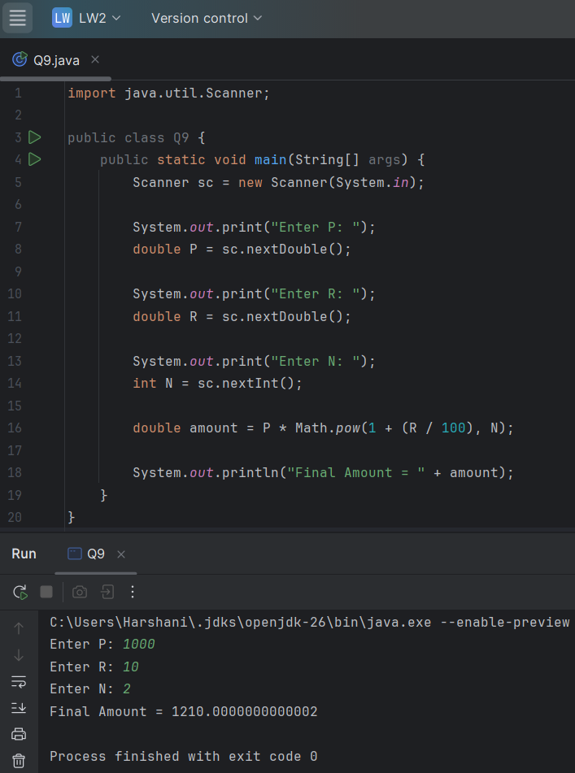
10. Write a loan calculator program that computes both monthly and total payments for the given inputs loan amount, annual interest rate, and loan period.
1. monthlyInterestRate = annualInterestRate / 100.0 / MONTHS_IN_YEAR;
2. numberOfPayments = loanPeriod * MONTHS_IN_YEAR;
3. monthlyPayment = (loanAmount * monthlyInterestRate) / (1 - Math.pow( 1 /(1 + monthlyInterestRate), numberOfPayments) );
4. totalPayment = monthlyPayment * numberOfPayments;

